Roxas, Renz Joseph Y.

BSIT 3B

1. **Make a program that adds two numbers.**

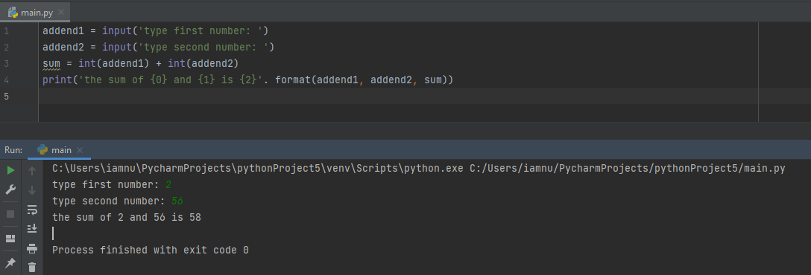

1. **Make a Python program to find the area of Triangle.**

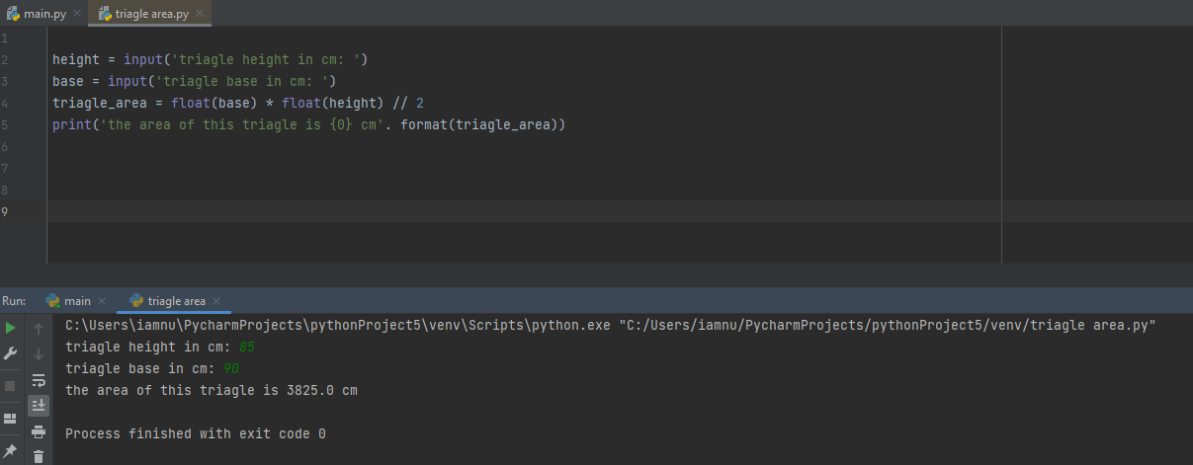

**Proof that the answer of the program is correct :)**

